Given a string s consisting of words and spaces, return the length of the ****last**** word in the string.

A ****word**** is a maximal

substring

 consisting of non-space characters only.

****Example 1:****

**Input:** s = "Hello World"**Output:** 5**Explanation:** The last word is "World" with length 5.

****Example 2:****

**Input:** s = " fly me to the moon "**Output:** 4**Explanation:** The last word is "moon" with length 4.

****Example 3:****

**Input:** s = "luffy is still joyboy"**Output:** 6**Explanation:** The last word is "joyboy" with length 6.

****Constraints:****

* 1 <= s.length <= 104
* s consists of only English letters and spaces ' '.
* There will be at least one word in s.

Source code:

class Solution:

    def lengthOfLastWord(self, s: str) -> int:

        S=s.strip()

        res=S.split()

        return len(res[-1])

Output:

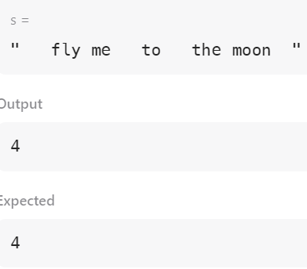

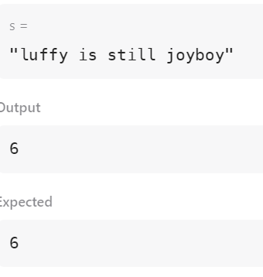

2)

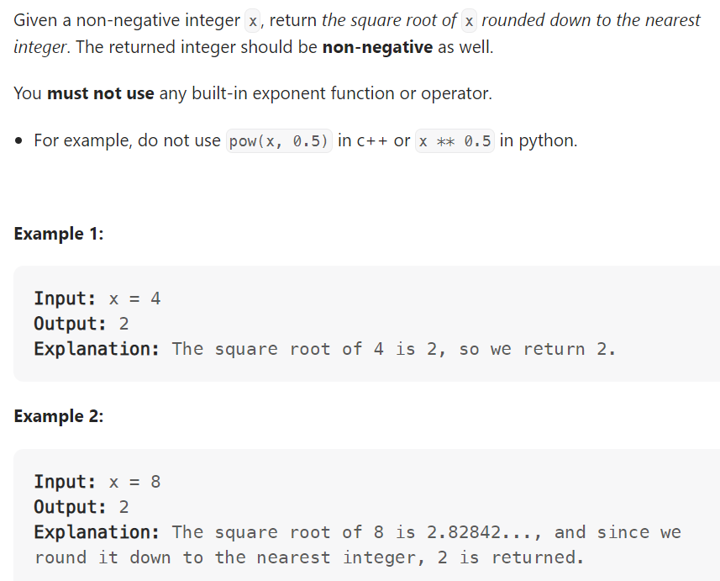

Source code:

class Solution:

    def mySqrt(self, x: int) -> int:

        return floor(math.sqrt(x))

3)

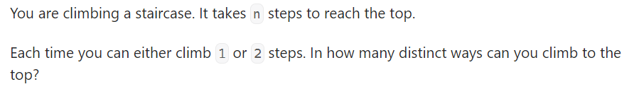

Code:

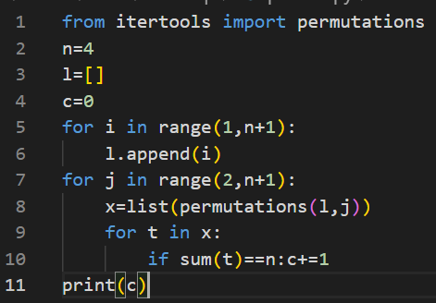

Output:

